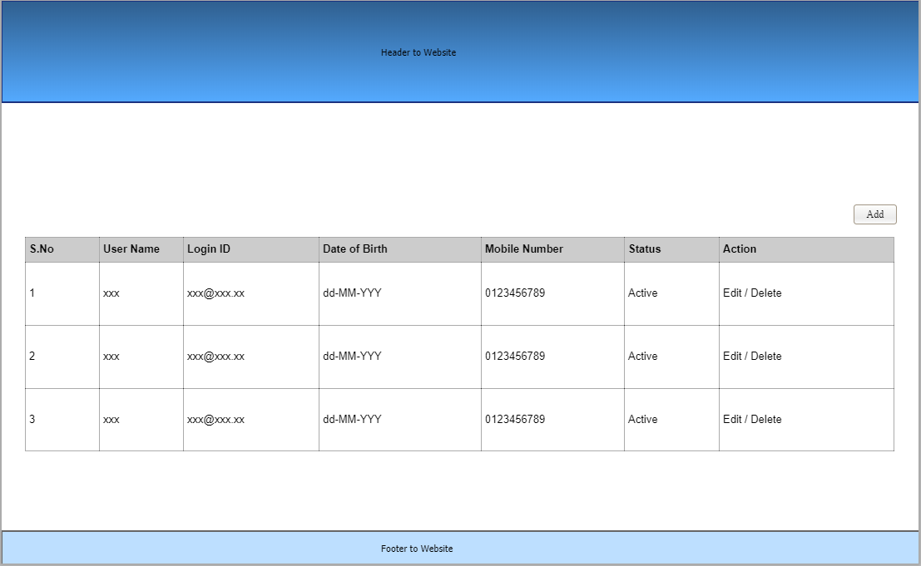

1. Apply HTML5, CSS3 and fontawesome to the above image, Site should be a responsive but should not use Bootstrap. Apply your own thoughts for the responsive grid.
2. Header menu should contains
   1. Home
   2. About Us
   3. Users – the above grid under this menu
3. You can use dummy text to Home and About Us pages.
4. Add Button
   1. While the button is clicked, Popup should open where you provide the inputs for the grid
   2. Popup should have – Save/Update and clear buttons
      1. When Save/Update button is clicked – data should auto populate/reflect in grid and then the popup should close. Validation for the form is important. Don’t use external plug-in do the validations on your own.
      2. When Clear button is clicked – the form should be cleared but the popup should not close.
5. Edit – When clicked, the same add form should be opened with pre-populated data
6. Delete – When delete button is clicked against the particular record the respective row should be deleted.
7. Provide a popup close functionality.
8. You may or may not use jquery plugin for the popup.
9. Search field should be included above the grid. Search function should be against Login ID.
10. Grid should be designed only with HTML, CSS and JS. Grid data should be manipulate by Object should not be DOM. Plugin should not be used.

Note: your submission should not validate, if not use Object handling, may include bootstrap, may wrote jquery.